**2**

**Motion in One Dimension**

|  |
| --- |
| **CHAPTER OUTLINE** |

2.1 Position, Velocity, and Speed of a Particle

2.2 Instantaneous Velocity and Speed

2.3 Analysis Model: Particle Under Constant Velocity

2.4 The Analysis Model Approach to Problem Solving

2.5 Acceleration

2.6 Motion Diagrams

2.7 Analysis Model: Particle Under Constant Acceleration

2.8 Freely Falling Objects

2.9 Kinematic Equations Derived from Calculus

* An asterisk indicates a question or problem new to this edition.

|  |
| --- |
| **SOLUTIONS TO THINK-PAIR-SHARE AND ACTIVITIES** |

*TP2.1 **Conceptualize** The photo in Figure TP2.1 helps you to visualize the situation. In the first demonstrations, the object, which appears as a small silver-colored slider at the left end of the red lever in the photograph, rises up and just touches the bell at the top of the column. We can approximate this situation by saying that the slider just reaches zero velocity at the position of the bell. In the final demonstration, the hitting of the hammer on the apparatus has caused the bell to shift to the side, so that the slider can fly vertically off the track when it is projected with a higher initial velocity. It looks like we have only two pieces of information: the height *h* of the object in the first situation and the fact that the initial velocity of the object in the second situation is twice that in the first. But we have two more pieces of information that can be gleaned from the description: in the first situation, the velocity of the object goes to zero just as its vertical position reaches height *h*; in the second situation, the initial and final vertical positions are the same.

**Categorize** The slider is an object in free fall, so we use the *particle under constant acceleration* model for its motion.

**Analyze** For the first situation, write an equation from the model relating velocity and position, using subscripts 1 to describe this situation. Evaluate the final values in the equation for the instant at which the object just touches the bell and momentarily comes to rest:

 (1)

For the second situation, write an equation from the model relating velocity and time, using subscripts 2. Solve for the time:

 (2)

Now evaluate the time at which the object reaches its highest position at the top of its motion:

 (3)

Recognize that the initial velocity in the second situation is twice that of the first, and combine Equations (1) and (2):



Finally, recognize by symmetry that the time at which the object lands back on the ground is twice that at which it is at the top, and substitute numerical values:



**Finalize** Does this time interval for the flight of the object seem reasonable? Discuss with your partners the following. Is this time just twice the time for the object to fall back to the lever in the first situation? In the second situation, does the object rise to a maximum height of just twice that in the first situation? Does the fact that the object begins its upward motion a few centimeters above the ground make any significant difference in our calculation of the final time in the second situation?

*Answer:* 3.83 s

*TP2.2 **Conceptualize** Be sure you understand the setup of the problem. One person drops a rock from rest. The second person waits for a time interval and then throws the second rock with just the right speed so that it catches up to the first rock just as the two rocks enter the water.

**Categorize** The rocks are in free fall, so we use the *particle under constant acceleration* model for their motion.

**Analyze** Let us first look at the fall of the first rock through the vertical distance *h*. Using Equation 2.16, rewritten for the vertical direction, we find

 (1)

This is the time at which the dropped rock strikes the water. Now consider the fall of the second rock. The thrower waits for a time interval ∆*t* after the first rock is dropped before throwing his rock downward. Let us denote time *t*’ as the time at which the second rock reaches the water, with *t*’ = 0 at the instant the second rock is thrown downward. Using Equation 2.16, rewritten for the vertical direction, we find



In order for there to be a single splash, the time *t* at which the first rock strikes the water must be the same as the sum of the waiting time ∆*t* and the time *t*’ for the second rock to fall:

 (3)

Substitute Equation (3) into Equation (2) and then substitute Equation (1) into Equation (2):

 (4)

(a) Substitute numerical values:



(b) One way to solve this problem is to solve Equation (4) for ∆*t*. This leads to a quadratic equation whose appropriate solution is

 (5)

Substitute numerical values:



Another way to solve the problem is to set up a spreadsheet using Equation (4) and generate a list of velocities *vyi* for increasing values of ∆*t*. You can then look in the list for the speed for 40.0 m/s and read the approximate value of ∆*t*. Then the spreadsheet can be modified by looking at just the short range of ∆*t* that gives a speed of about 40.0 m/s and using a smaller increment for ∆*t*. By narrowing in using this technique, you find again that the time interval is 2.34 s.

(c) The second rock must be thrown before the first rock hits the water. Therefore, the longest time interval is given by Equation (1):



Substitute numerical values:



**Finalize** If the second person waited to throw the second rock for the time interval in part (c), it would have to be thrown with infinite speed. (We will find in Chapter 38 that this is not possible.) If you have set up the spreadsheet for part (b), you will see the values for the speed *vyi* become very large as you approach 3.91 s and then become negative for larger values of the time interval.

*Answers:* (a) 11.5 m/s (b) 2.34 s (c) 3.91 s

*TP2.3 **Conceptualize** Think about the falling ruler. When it begins to fall, your eyes see the motion and send a signal to your brain. Your brain has to process the information and send a signal to your hand to grab the ruler. The muscles in your hand then have to respond to this signal and close your fingers onto the ruler. The time intervals for all of these things to happen are added to equal the reaction time.

**Categorize** The ruler falls with an acceleration due to gravity, so we use the *particle under constant acceleration* model for its motion.

**Analyze** There are no numbers given in the problem, so let’s make one up. Suppose your fingers close on the ruler at the 8.0-inch mark. Then, using Equation 2.16 in the vertical direction,



Substitute the value of *h*:



**Finalize** This value is a typical human reaction time.

*Answer:* Answers will vary depending on your individual reaction time. A typical human reaction time is about 0.2 s.

*TP2.4 **Conceptualize** From the graphical representation, generate a mental representation by running the motion in your mind. (a) From –50 s to 0, the Acela is cruising at a constant positive velocity in the +*x* direction. Between 0 and 50 s, the constant velocity is maintained for a while and then the train begins to speed up. Between 50s and 100s, the train speeds up; notice that the graph is linear in this segment. Between 100 s and 200 s, the train reaches its maximum speed of about 175 mi/h. Between 200 s and 300 s, the engineer applies the brakes: the train is slowing down. The train is moving very slowly between 300 s and 350 s and then stops at 350 s. After 350 s, the train reverses direction: the velocity is negative. The train is backing up faster and faster until the data ends at 400 s.

**Categorize** Much of the motion of the train does not fit into a simple analysis model. However, between 50 s and 100 s, the train is well modeled as a *particle under constant acceleration,* since the *v*–*t* graph is linear.

**Analyze** (b) Draw a best-fit line between 50 s and 100 s on the graph, taking advantage of the full vertical extent of the graph:

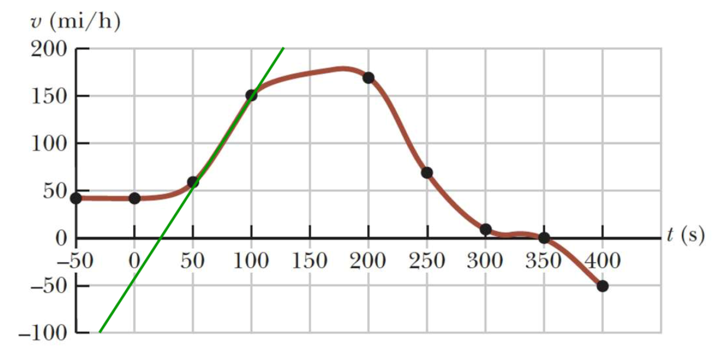

Now, find the slope of the green line, using its topmost and bottommost points, reading the coordinates from the graph:



This result can be converted to metric units:



(c) To find the displacement, we need to use the notion in Section 2.9 that the displacement of a particle is the area under the *v*–*t* curve. Because we do not have a functional description of the velocity of the train, we will need to approximate the displacement. Let’s approximate the area under the curve between 0 and 200 s with the following triangle (yellow) and two rectangles (green):

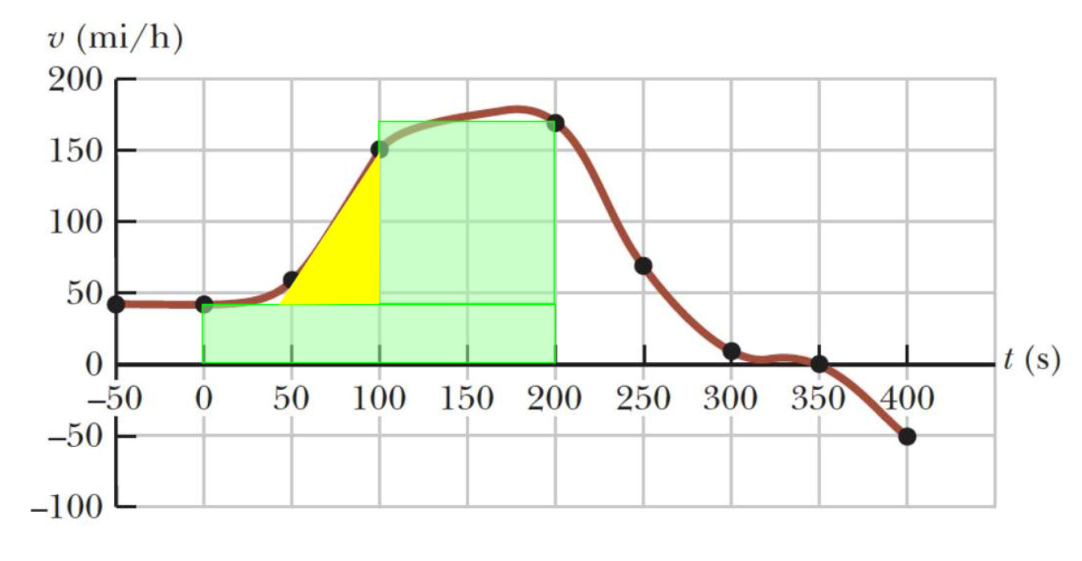

Find the area of each shape:

Lower rectangle:



Upper rectangle:



Triangle:



Therefore, the total displacement is



This is not a very useful unit! So let’s reconcile the hours and seconds:



**Finalize** There are a variety of ways that the area under the curve in part (c) could be approximated, so the results may vary a bit depending on how this approximation is made.

*Answers:* (a) From –50 s to 0, the Acela is cruising at a constant positive velocity in the +*x* direction. Between 0 and 50 s, the constant velocity is maintained for a while and then the train begins to speed up. Between 50s and 100s, the train speeds up; notice that the graph is linear in this segment. Between 100 s and 200 s, the train reaches its maximum speed of about 175 mi/h. Between 200 s and 300 s, the engineer applies the brakes: the train is slowing down. The train is moving very slowly between 300 s and 350 s and then stops at 350 s. After 350 s, the train reverses direction: the velocity is negative. The train is backing up faster and faster until the data ends at 400 s. (b) 0.87 m/s2 (c) 6.7 mi (answers may vary, depending on estimation from the graph.)

|  |
| --- |
| **SOLUTIONS TO END-OF-CHAPTER PROBLEMS** |

Section 2.1 Position, Velocity, and Speed

P2.1 We assume that you are approximately 2 m tall and that the nerve impulse travels at uniform speed. The elapsed time is then



P2.2 We substitute for *t* in *x* = 10*t*2, then use the definition of average velocity:

|  |  |  |  |
| --- | --- | --- | --- |
| *t* (s) | 2.00 | 2.10 | 3.00 |
| *x* (m) | 40.0 | 44.1 | 90.0 |

(a) 

(b) 

P2.3 We read the data from the table provided, assume three significant figures of precision for all the numbers, and use Equation 2.2 for the definition of average velocity.

(a) 

(b) 

(c) 

Section 2.2 Instantaneous Velocity and Speed

P2.4 We use the definition of average velocity.

(a) 

(b) 

(c) To find the average velocity for the round trip, we add the displacement and time for each of the two halves of the swim:



(d) The average speed of the round trip is the total distance the athlete travels divided by the total time for the trip:



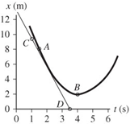P2.5 For average velocity, we find the slope of a secant line running across the graph between the 1.5-s and 4-s points. Then for instantaneous velocities we think of slopes of tangent lines, which means the slope of the graph itself at a point.

**ANS. FIG. P2.5**

We place two points on the curve: Point A, at   
*t* = 1.5 s, and Point B, at *t* = 4.0 s, and read the corresponding values of *x*.

(a) At *ti* = 1.5 s, *xi* = 8.0 m (Point A)

At *tf* = 4.0 s, *xf* = 2.0 m (Point B)



(b) The slope of the tangent line can be found from points *C* and *D*. (*tC* = 1.0 s, *xC* = 9.5 m) and (*tD* = 3.5 s, *xD* = 0),



The negative sign shows that the **direction** of *vx*is along the negative *x* direction.

(c) The velocity will be zero when the slope of the tangent line is zero. This occurs for the point on the graph where *x* has its minimum value. This is at .

Section 2.3 Analysis Model: Particle Under Constant Velocity

P2.6 The trip has two parts: first the car travels at constant speed *v*1 for distance *d*, then it travels at constant speed *v*2 for distance *d*. The first part takes the time interval  = *d/v*1, and the second part takes the time interval ∆*t*2 = *d/v*2.

(a) By definition, the average velocity for the entire trip is  where  and  Putting these together, we have



We know *v*avg = 30 mi/h and *v*1 = 60 mi/h.

Solving for *v*2 gives



(b) The average velocity for this trip is  where   
 so, *v*avg=

(c) The average speed for this trip is where *d* = *d*1 + *d*2 =   
*d* + *d* = 2*d* and  so, the average speed is the same as in part (a): *v*avg = 

**P2.7** (a) The total time for the trip is *t*total = *t*1 + 22.0 min = *t*1 + 0.367 h, where *t*1 is the time spent traveling at *v*1 = 89.5 km/h. Thus, the distance traveled is  which gives



or



from which, *t*1= 2.44 h, for a total time of



(b) The distance traveled during the trip is  giving



Section 2.5 Acceleration

P2.8 The acceleration is zero whenever the marble is on a horizontal section. The acceleration has a constant positive value when the marble is rolling on the 20-to-40-cm section and has a constant negative value when it is rolling on the second sloping section. The position graph is a straight sloping line whenever the speed is constant and a section of a parabola when the speed changes.

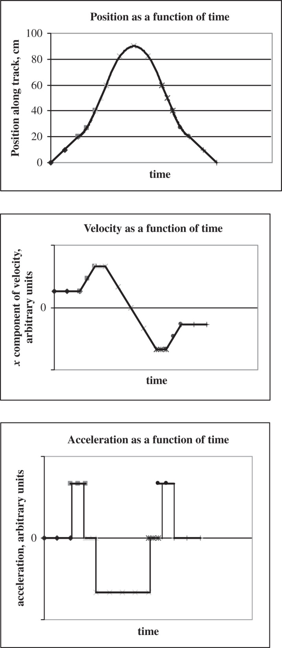

**P2.9** (a) In the interval *ti* = 0 s and *tf* = 6.00 s, the motorcyclist’s velocity changes from *vi* = 0 to *vf* = 8.00 m/s. Then,



(b) Maximum positive acceleration occurs when the slope of the velocity-time curve is greatest, at *t* = 3 s, and is equal to the slope of the graph, approximately (6 m/s – 2 m/s)/(4 s − 2 s) = 

(c) The acceleration *a* = 0 when the slope of the velocity-time graph is zero, which occurs at , and also for 

(d) Maximum negative acceleration occurs when the velocity-time graph has its maximum negative slope, at *t* = 8 s, and is equal to the slope of the graph, approximately 

**P2.10** (a) The graph is shown in ANS. FIG. P2.10 below.

|  |  |
| --- | --- |
|  |  |
| **ANS. FIG. P2.10** | |

(b) At *t* = 5.0 s, the slope is .

At *t* = 4.0 s, the slope is .

At *t* = 3.0 s, the slope is .

At *t* = 2.0 s, the slope is .

(c) 

(d) The initial velocity of the car was .

P2.11 (a) The area under a graph of *a* vs. *t* is equal to the change in velocity, ∆*v*. We can use Figure P2.19 to find the change in velocity during specific time intervals.

The area under the curve for the time interval 0 to 10 s has the shape of a rectangle. Its area is

 = (2 m/s2)(10 s) = 20 m/s

The particle starts from rest, *v*0 = 0, so its velocity at the end of the 10-s time interval is

*v* = *v*0 +  = 0 + 20 m/s = 

Between *t* = 10 s and *t* = 15 s, the area is zero:  = 0 m/s.

Between *t* = 15 s and *t* = 20 s, the area is a rectangle:  =   
(−3 m/s2)(5 s) = −15 m/s.

So, between *t* = 0 s and *t* = 20 s, the total area is  = (20 m/s) +   
(0 m/s) + (−15 m/s) = 5 m/s, and the velocity at *t* = 20 s is 

(b) We can use the information we derived in part (a) to construct a graph of *x* vs. *t*; the area under such a graph is equal to the displacement,  of the particle.

From (a), we have these points (*t*, *v*) = (0 s, 0 m/s), (10 s, 20 m/s), (15 s, 20 m/s), and (20 s, 5 m/s). The graph appears below.

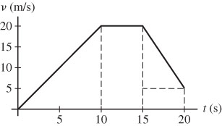

The displacements are:

0 to 10 s (area of triangle):  = (1/2)(20 m/s)(10 s) = 100 m

10 to 15 s (area of rectangle):  = (20 m/s)(5 s) = 100 m

15 to 20 s (area of triangle and rectangle):

 = (1/2)[(20 – 5) m/s](5 s) + (5 m/s)(5 s)

= 37.5 m + 25 m = 62.5 m

Total displacement over the first 20.0 s:

 = 100 m + 100 m + 62.5 m = 262.5 m = 

Section 2.6 Motion Diagrams

P2.12 (a) 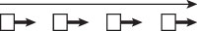

(b) 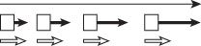

(c) 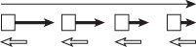

(d) 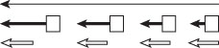

(e) 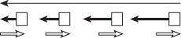

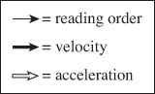

(f) One way of phrasing the answer: The spacing of the successive positions would change with 

Another way: The object would move with some combination of the kinds of motion shown in (a) through (e). Within one drawing, the acceleration vectors would vary in magnitude and direction.

P2.13 (a) The motion is fast at first but slowing until the speed is constant. We assume the acceleration is constant as the object slows.

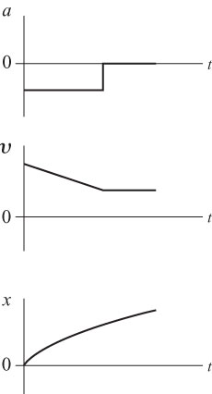

(b) The motion is constant in speed.

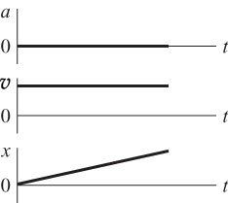

(c) The motion is speeding up, and we suppose the acceleration is constant.

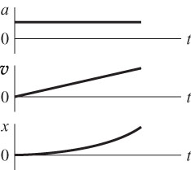

Section 2.7 Analysis Model: Particle Under Constant Acceleration

P2.14 We have   and 

(a) 



(b) :



**P2.15** In parts (a) – (c), we use Equation 2.13 to determine the velocity at the times indicated.

(a) The time given is 1.00 s after 10:05:00 a.m., so

*vf* = *vi* + *at* = 13.0 m/s + (–4.00 m/s2)(1.00 s) = 

(b) The time given is 4.00 s after 10:05:00 a.m., so

*vf* = *vi* + *at* = 13.0 m/s + (–4.00 m/s2)(4.00 s) = 

(c) The time given is 1.00 s before 10:05:00 a.m., so

*vf* = *vi* + *at* = 13.0 m/s + (–4.00 m/s2)(–1.00 s) = 

(d) 

(e) 

**P2.16** We think of the plane moving with maximum-size backward acceleration throughout the landing, so the acceleration is constant, the stopping time a minimum, and the stopping distance as short as it can be. The negative acceleration of the plane as it lands can be called deceleration, but it is simpler to use the single general term *acceleration* for all rates of velocity change.

(a) The plane can be modeled as a particle under constant acceleration, with  Given   we use the equation ** and solve for *t*:



(b) Find the required stopping distance and compare this to the length of the runway. Taking *xi* to be zero, we get



or 

(c) The stopping distance is greater than the length of the runway; 

**P2.17** The velocity is always changing; there is always nonzero acceleration and the problem says it is constant. So we can use one of the set of equations describing constant-acceleration motion. Take the initial point to be the moment when *x*i= 3.00 cmand *vx*i = 12.0 cm/s. Also, at t = 2.00 s, *x*f = –5.00 cm.

Once you have classified the object as a particle moving with constant acceleration and have the standard set of four equations in front of you, how do you choose which equation to use? Make a list of all of the six symbols in the equations: *xi* , *xf*, *vxi* , *vxf*, *ax*, and *t*. On the list fill in values as above, showing that *xi*, *xf*, *vxi*, and *t* are known. Identify *ax* as the unknown. Choose an equation involving only one unknown and the knowns. That is, choose an equation *not* involving *vxf.* Thus we choose the kinematic equation

 

and solve for *a*x:



We substitute:



**P2.18** As in the algebraic solution to Example 2.8, we let *t* represent the time the trooper has been moving. We graph

*x*car = 45+ 45*t*

and *x*trooper = 1.5*t*2

They intersect at 

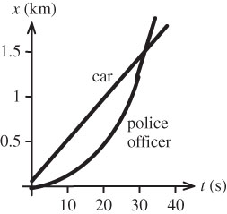

ans. Fig. P2.18

**P2.19** Let the glider enter the photogate with velocity *vi* and move with constant acceleration *a*. For its motion from entry to exit,



(a) The speed halfway through the photogate in space is given by



 and this is 

(b) The speed halfway through the photogate in time is given by  and this is  as determined above.

**P2.20** We ask whether the constant acceleration of the rhinoceros from rest over a period of 10.0 s can result in a final velocity of 8.00 m/s and a displacement of 50.0 m? To check, we solve for the acceleration in two ways.

1) *ti* = 0, *vi* = 0; *t* = 10.0 s, *vf* = 8.00 m/s:



2) *ti* = 0, *xi* = 0, *vi* = 0; *t* = 10.0 s, *xf* = 50.0 m:





**P2.21** (a) Let a stopwatch start from *t* = 0 as the front end of the glider passes point A. The average speed of the glider over the interval between *t* = 0 and *t* = 0.628 s is 12.4 cm/(0.628 s) = , and this is the instantaneous speed halfway through the time interval, at *t* = 0.314 s.

(b) The average speed of the glider over the time interval between 0.628 + 1.39 = 2.02 s and 0.628 + 1.39 + 0.431 = 2.45 s is   
12.4 cm/(0.431 s) = 28.8 cm/s and this is the instantaneous speed at the instant *t* = (2.02 + 2.45)/2 = 2.23 s.

Now we know the velocities at two instants, so the acceleration is found from



(c) 

**P2.22** Take any two of the standard four equations, such as



Solve one for *vxi*, and substitute into the other:

*vxi = vxf – axt*



Thus



We note that the equation is dimensionally correct. The units are units of length in each term. Like the standard equation  this equation represents that displacement is a quadratic function of time.

**P2.23** (a) For the first car, the speed as a function of time is



For the second car, the speed is

**

Setting the two expressions equal gives



Solving for *t* gives



(b) The first car then has speed



and this is also the constant speed of the second car.

(c) For the first car, the position as a function of time is

**

For the second car, the position is

**

At the point where the cars pass one another, their positions are equal:



rearranging gives



We solve this with the quadratic formula. Suppressing units,



(d) At *t* = 0.604 s, the second and also the first car’s position is

**

At *t* = 6.90 s, both are at position



(e) 

**\*P2.24**

**Solution**

**Conceptualize**  A diagram of the information provided will be helpful. The diagram below shows three positions of the car and the times at which the car is at those positions.

**Categorize** The phrase “slowing down the car uniformly” tells us to use the particle under constant acceleration analysis model for this problem.

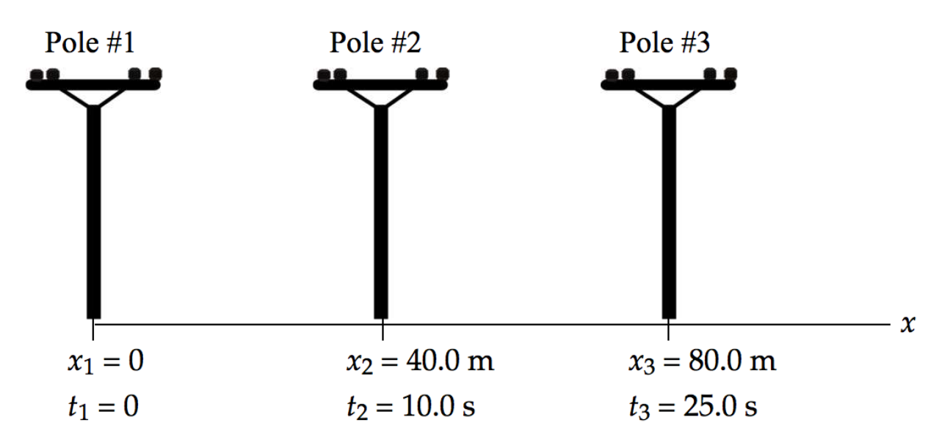

**Analyze** We have no information about the velocity of the car, so that suggests we focus on the equation in the particle under constant acceleration model involving position: . (a) Write the position equation twice, once for the car at pole #2 and once at pole #3, each referencing pole #1 as the initial situation:

 (1)

 (2)

Eliminate *v*1 between Equations (1) and (2) and solve for the acceleration *a*:

 (3)

Substitute numerical values:



(b) Solve Equation (1) for the initial speed of the car:

 (4)

Substitute numerical values:



(c) Using Equation 2.17 in the particle under constant acceleration model relating velocity and position, solve for the position at which the velocity goes to zero:



Because the fourth pole would be at *x* = 120 m, the last pole passed is pole #3.

**Finalize** Part (c) can also be solved less directly by finding the time at which the velocity goes to zero and then substituting into the position equation to find the position at that time. In doing so, you find the time at which the car stops to be 42.5 s. It might be surprising that the car travels for an additional 42.5 – 25.0 = 17.5 s beyond pole #3 (longer than between poles #1 and #2, and between poles #2 and #3), but only moves 96.3 – 80.0 m = 16.3 m beyond that pole.

*Answers:* (a)–0.107 m/s2(b) 4.53 m/s (c) pole #3 (stops at *x* = 96.3 m at *t* = 42.4 s

Section 2.8 Freely Falling Objects

**P2.25** The bill starts from rest, *vi* = 0, and falls with a downward acceleration of 9.80 m/s2 (due to gravity). For an average human reaction time of about 0.20 s, we can find the distance the bill will fall:



The bill falls about 20 cm—this distance is about twice the distance between the center of the bill and its top edge, about 8 cm. Thus 

**P2.26** We can solve (a) and (b) at the same time by assuming the rock passes the top of the wall and finding its speed there. If the speed comes out imaginary, the rock will not reach this elevation.



which gives 

.

(c) The rock travels from *yi* = 3.65 m to *yf* = 1.55 m. We find the final speed of the rock thrown down:



which gives 

The change in speed of the rock thrown down is



(d) The magnitude of the speed change of the rock thrown up is  This  with   
2.39 m/s.

(e) 

**P2.27** We are given the height of the helicopter: *y* = *h* = 3.00*t*3.

At *t* = 2.00 s, *y* = 3.00(2.00 s)3 = 24.0 m and



If the helicopter releases a small mailbag at this time, the mailbag starts its free fall with velocity 36.0 m/s upward. The equation of motion of the mailbag is



Setting *yf* = 0, dropping units, and rearranging the equation, we have

4.90*t*2 – 36.0*t* – 24.0 = 0

We solve for *t* using the quadratic formula:



Since only positive values of *t* count, we find 

**P2.28** The falling ball moves a distance of (15 m – *h*) before they meet, where *h* is the height above the ground where they meet. We apply



to the falling ball to obtain



or  **[1]**

Applying  to the rising ball gives

 **[2]**

Combining equations [1] and [2] gives



or 

**P2.29** We model the keys as a particle under the constant free-fall acceleration. Take the first student’s position to be  and the second student’s position to be  We are given that the time of flight of the keys is *t* = 1.50 s, and .

(a) We choose the equation  to connect the data and the unknown.

We solve:



and substitute:



(b) The velocity at any time *t* > 0 is given by *vyf* = *vyi* + *ayt.*

Therefore, at *t* =1.50 s,



The negative sign means that the keys are moving **downward** just before they are caught.

**P2.30** (a) The keys, moving freely under the influence of gravity (*a* = −*g*), undergo a vertical displacement of ∆*y* = +*h* in time *t*. We use  to find the initial velocity as



(b) We find the velocity of the keys just before they were caught (at time *t*) using *v* = *vi* + *at*:



**\*P2.31**

**Solution:**

**Conceptualize** This is a simple situation in which an object is thrown straight upward and is in free fall after being thrown. We wish to relate the speed of the throw and the height of the projectile.

**Categorize** We recognize a simple one-dimensional free-fall problem, in which we use the *particle under constant acceleration* model for the motion of the box.

**Analyze** (a) From the particle under constant acceleration model, chose the equation that relates position and equation (Equation 2.17), noting that the motion is in the *y* direction:

 (1)

Consider the point at which the box reaches its highest position. Note that the velocity of the box at that position is *vyf* = 0, and define the point at which the box is thrown as the origin, so that *yi* = 0. Also assign the acceleration to be that due to gravity, so that Equation (1) becomes

 (2)

Find the highest position for the box if thrown upward at the speed of 20.0 m/s found in the demonstration:



Because this position is higher than the bottom of the window in which the alleged accomplice caught the box, the action of throwing the box to the accomplice is possible.

(b) The defense attorney could argue as follows: The demonstration involved throwing a baseball horizontally. It is more difficult to throw something upward, so the throwing speed could be in error. You might counter-argue that the throwing speed could actually be higher because the defendant was attempting to minimize his throwing speed during the demonstration in order to show that the feat could not be done.

*Answers:* (a) The box could reach the window according to the data provided.(b) Answers will vary.

Section 2.9 Kinematic Equations Derived from Calculus

**P2.32** (a) See the *x* vs. *t* graph on the top panel of ANS. FIG. P2.32. Choose *x* = 0 at *t* = 0.



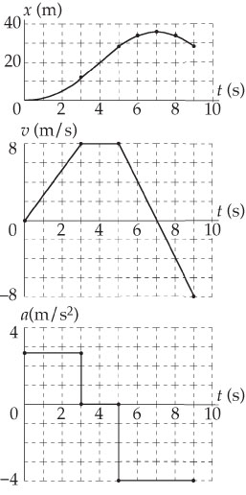 (b) See the *a* vs. *t* graph at the bottom right.



For 3 < *t* < 5 s, *a* = 0.

At the points of inflection, *t* = 3 and 5 s, the slope of the velocity curve changes abruptly, so the acceleration is not defined.

**ANS. FIG. P2.32**

(c) For 5 s < *t* < 9 s,



(d) The average velocity between *t* = 5 and 7 s is

*v*avg = (8 m/s +0)/2 = 4 m/s

At 

(e) The average velocity between *t* = 5 and 9 s is

*v*avg = [(8 m/s) + (−8 m/s)]/2 = 0 m/s

At *t* = 9 s, *x* = 28 m + (0 m/s)(1 s) = 

**P2.33** This is a derivation problem. We start from basic definitions. We are given *J* = *dax*/*dt* = constant, so we know that *dax* = *Jdt*.

(a) Integrating from the ‘initial’ moment when we know the acceleration to any later moment,



Therefore, 

From *ax* = *dvx*/*dt*, *dvx* = *ax dt.*

Integration between the same two points tells us the velocity as a function of time:





From *vx* = *dx*/*dt*, *dx* = *vxdt*. Integrating a third time gives us *x*(*t*):





and 

(b) Squaring the acceleration,



Rearranging,



The expression for *vx* was



So 

and by substitution 



Additional Problems

**P2.34** (a) Area *A*1 is a rectangle. Thus, *A*1 = *hw* = *vxit*.

Area *A*2 is triangular. Therefore, 

The total area under the curve is



and since *vx* – *vxi* = *axt,*



(b) 

**P2.35** (a) From  the insect’s velocity after straightening its legs is



(b) The time to reach this velocity is



(c) The upward displacement of the insect between when its feet leave the ground and its speed is momentarily zero is



**P2.36** Take downward as the positive *y* direction.

(a) While the woman was in free fall,   and we take  Thus,



giving  Her velocity just before impact is:



(b) While crushing the box, , , and  Therefore,



or 

(c) Time to crush box:



or 

**P2.37** (a) In order for the trailing athlete to be able to catch the leader, his speed (*v*1) must be greater than that of the leading athlete (*v*2), and the distance between the leading athlete and the finish line must be great enough to give the trailing athlete sufficient time to make up the deficient distance, *d*.

(b) During a time interval *t* the leading athlete will travel a distance *d*2 = *v*2*t* and the trailing athlete will travel a distance *d*1 = *v*1*t*. Only when *d*1 = *d*2 + *d* (where *d* is the initial distance the trailing athlete was behind the leader) will the trailing athlete have caught the leader. Requiring that this condition be satisfied gives the elapsed time required for the second athlete to overtake the first:

*d*1 = *d*2 + *d* or *v*1*t* = *v*2*t* + *d*

giving



(c) In order for the trailing athlete to be able to at least tie for first place, the initial distance *D* between the leader and the finish line must be greater than or equal to the distance the leader can travel in the time *t* calculated above (i.e., the time required to overtake the leader). That is, we must require that



**P2.38** For the collision not to occur, the front of the passenger train must not have a position that is equal to or greater than the position of the back of the freight train at any time. We can write expressions of position to see whether the front of the passenger car (P) meets the back of the freight car (F) at some time.

Assume at *t* = 0, the coordinate of the front of the passenger car is   
*x*P*i* = 0; and the coordinate of the back of the freight car is *x*F*i* = 58.5 m. At later time *t*, the coordinate of the front of the passenger car is



and the coordinate of the back of the freight car is



Setting these expression equal to each other gives



or 

after simplifying and suppressing units.

We do not have to solve this equation, we just want to check if a solution exists; if a solution does exist, then the trains collide. A solution does exist:





**P2.39** We have constant-acceleration equations to apply to the two cars separately.

(a) Let the times of travel for Hannah and Stan be *tK* and *tS*, where   
 *tS* = *tK* + 1.00 s

Both start from rest (*vxi,K* = *vxi,S* = 0), so the expressions for the distances traveled are



and 

When Hannah overtakes Stan, the two distances will be equal. Setting *xK = xS* gives



This we simplify and write in the standard form of a quadratic as



We solve using the quadratic formula , suppressing units, to find



Only the positive root makes sense physically, because the overtake point must be after the starting point in time.

(b) Use the equation from part (a) for distance of travel,



(c) Remembering that *vxi,K* = *vxi,S* = 0, the final velocities will be:





**P2.40** We translate from a pictorial representation through a geometric model to a mathematical representation by observing that the distances *x* and *y* are always related by *x2+* *y*2 = *L*2 .

(a)Differentiating this equation with respect to time, we have



Now the unknown velocity of B is  and 

so the differentiated equation becomes



But  so 

(b) 

**P2.41** The average speed of every point on the train as the first car passes Lisa is given by:



The train has this as its instantaneous speed halfway through the 1.50-s time. Similarly, halfway through the next 1.10 s, the speed of the train is . The time required for the speed to change from 5.73 m/s to 7.82 m/s is



so the acceleration is: 

Challenge Problems

**P2.42** (a) The factors to consider are as follows. The red bead falls through a greater distance with a downward acceleration of *g*. The blue bead travels a shorter distance, but with acceleration of  A first guess would be that the blue bead “wins,” but not by much. We do note, however, that points , , and  are the vertices of a right triangle with  as the hypotenuse.

(b) The red bead is a particle under constant acceleration. Taking downward as the positive direction, we can write



as 

which gives 

(c) The blue bead is a particle under constant acceleration, with  Taking the direction along *L* as the positive direction, we can write



as 

which gives 

(d) For the two beads to reach point  simultaneously, *t*R = *t*B. Then,



Squaring both sides and cross-multiplying gives



or 

We note that the angle between chords  and  is  so that the angle between chords  and  is  Then,  and the beads arrive at point  simultaneously.

(e) Once we recognize that the two rods form one side and the hypotenuse of a right triangle with  as its smallest angle, then the result becomes obvious.

**P2.43** Consider the runners in general. Each completes the race in a total time interval *T*. Each runs at constant acceleration *a* for a time interval  so each covers a distance (displacement)  where they eventually reach a final speed (velocity)  after which they run at this constant speed for the remaining time  until the end of the race, covering distance  The total distance (displacement) each covers is the same:



so 

where  and *T* = 10.4 s.

(a) For Laura (runner 1),  = 2.00 s:

*a*1 = (100 m)/(18.8 s2) = 

For Healan (runner 2),  = 3.00 s:

*a*2 = (100 m)/(26.7 s2) = 

(b) Laura (runner 1): *v*1 = *a*1 = 

Healan (runner 2): *v*2 = *a*2 = 

(c) The 6.00-s mark occurs after either time interval  From the reasoning above, each has covered the distance



where *t* = 6.00 s.

Laura (runner 1):  = 53.19 m

Healan (runner 2): = 50.56 m



(d) Laura accelerates at the greater rate, so she will be ahead of Healen at, and immediately after, the 2.00-s mark. After the 3.00-s mark, Healan is travelling faster than Laura, so the distance between them will shrink. In the time interval 

During that time interval, the distance between them (the position of Laura relative to Healan) is



because Laura has ceased to accelerate but Healan is still accelerating. Differentiating with respect to time, (and doing some simplification), we can solve for the time *t* when *D* is an maximum:



which gives



Substituting this time back into the expression for *D*, we find that *D* = 4.47 m, that is, Laura ahead of Healan by 

**\*P2.44** (a) Starting from rest and accelerating at *ab* = 13.0 mi/h · s, the bicycle reaches its maximum speed of *vb*,max = 20.0 mi/h in a time



Since the acceleration *ac* of the car is less than that of the bicycle, the car cannot catch the bicycle until some time *t* > *tb*,1 (that is, until the bicycle is at its maximum speed and coasting). The total displacement of the bicycle at time *t* is



The total displacement of the car at this time is



At the time the car catches the bicycle,  This gives



or 

that has only one physically meaningful solution *t* > *tb*,1. This solution gives the total time the bicycle leads the car and is 

(b) The lead the bicycle has over the car continues to increase as long as the bicycle is moving faster than the car. This means until the car attains a speed of *vc* = *vb*,max = 20.0 mi/h. Thus, the elapsed time when the bicycle’s lead ceases to increase is



At this time, the lead is



or 

|  |
| --- |
| **ANSWERS TO QUICK-QUIZZES** |

1. (b)

2. (c)

3. (b)

4. False.

5. (b)

6. (c)

7. (a)–(e), (b)–(d), (c)–(f)

8. (i) (e) (ii) (d)

|  |
| --- |
| **ANSWERS TO EVEN-NUMBERED PROBLEMS** |

P2.2 (a) 50.0 m/s; (b) 41.0 m/s

P2.4 (a) +*L*/*t*1; (b) –*L*/*t*2; (c) 0; (d) 2*L*/*t*1+ *t*2

P2.6 (a) 20 mi/h; (b) 0; (c) 30 mi/h

P2.8 See graphs in P2.8.

P2.10 (a) See ANS. FIG. P2.18; (b) 23 m/s, 18 m/s, 14 m/s, and 9.0 m/s; (c) 4.6 m/s2; (d) zero

P2.12 (a–e) See graphs in P2.22; (f) with less regularity

P2.14 (a) 4.98×10-19s (b) 1.20×1015m/s2

P2.16 (a) 20.0s (b) 1000m (c) the plane cannot land

P2.18 31s

P2.20 The accelerations do not match, therefore the situation is impossible.

P2.22 The equation represents that displacement is a quadratic function of time. 

P2.24 (a)–0.107 m/s2(b) 4.53 m/s (c) pole #3 (stops at *x* = 96.3 m at *t* = 42.4 s

P2.26 (a and b) The rock does not reach the top of the wall with vf = 3.69 m/s; (c) 2.39m/s; (d) does not agree; (e) The average speed of the upward-moving rock is smaller than the downward moving rock.

P2.28 0.60 s

P2.30 (a)  (b) 

P2.32 (a) See graphs in P2.58; (b) See graph in P2.58; (c) −4 m/s2; (d) 32 m;   
(e) 28 m

P2.34 (a)  (b) The displacement is the same result for the total area.

P2.36 (a) 96.0 ft/s; (b) ; (c) 

P2.38 The trains do collide.

P2.40 (a) *v*B = (1/tan u)*v* (b) The velocity *v*B starts off larger than *v* for small angles theta and then decreases, approaching zero as theta approaches 90°.

P2.42 (a) The red bead falls through a greater distance with a downward acceleration of *g*. The blue bead travels a shorter distance, but with acceleration of  A first guess would be that the blue bead “wins,” but not by much. (b)  (c)  (d) the beads arrive at point  simultaneously; (e) Once we recognize that the two rods form one side and the hypotenuse of a right triangle with  as its smallest angle, then the result becomes obvious.

P2.44 (a) 3.45 s; (b) 10.0 ft.